Laboratory Practice I

Data Analytics

Shiva Saran
BE-B 20
2020-2021

Practical 1
Download the Iris flower dataset or any other dataset into a DataFrame. (eg https://archive.ics.uci.edu/ml/datasets/Iris )

Use Python/R and Perform following –

How many features are there and what are their types (e.g., numeric, nominal)?

> View(iris)
> dim(iris)
[1] 150 5

> #..............1. data set details................
> #internal structure

> names(iris)
[1] "Sepal.Length" "Sepal.Width" "Petal.Length" "Petal.Width" "Species"

> str(iris)
'data.frame': 150 obs. of 5 variables:
$ Sepal.Length: num 5.1 4.9 4.7 4.6 5 5.4 4.6 5 4.4 4.9 ...
$ Sepal.Width : num 3.5 3 3.2 3.1 3.6 3.9 3.4 3.4 2.9 3.1 ...
$ Petal.Length: num 1.4 1.4 1.3 1.5 1.4 1.7 1.4 1.5 1.4 1.5 ...
$ Petal.Width : num 0.2 0.2 0.2 0.2 0.2 0.4 0.3 0.2 0.2 0.1 ...
$ Species : Factor w/ 3 levels "setosa","versicolor",..: 1 1 1 1 1 1 1 1 1 1 ...

Compute and display summary statistics for each feature available in the dataset (eg. minimum value, maximum value, mean, range, standard deviation, variance and percentiles)

> #..............2.statistics...................
> #min value
> min(iris$Sepal.Length)
[1] 4.3
>
> #max value
> max(iris$Sepal.Length)
[1] 7.9

> #range
> range(iris$Sepal.Length)
[1] 4.3 7.9
>
> #standard deviation
> sd(iris$Sepal.Length)
[1] 0.8280661
>
> #variance
> var(iris$Sepal.Length)
[1] 0.6856935

> #percentile
> quantile(iris$Sepal.Length)
0% 25% 50% 75% 100%
4.3 5.1 5.8 6.4 7.9
>
> #For specific
> quantile(iris$Sepal.Length, c(0.35,0.75))
35% 75%
5.5 6.4

Data Visualization-Create a histogram for each feature in the dataset to illustrate the
feature distributions. Plot each histogram.

1. Sepal Length

> hist(iris$Sepal.Length, main = "Sepal Length Frequencies", xlab ="Sepal Length", xlim = c(3.5,8.5), col="blue")

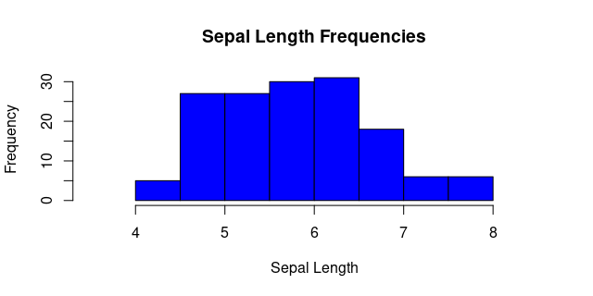

2. Sepal Width

> hist(iris$Sepal.Width, main = "Sepal Width Frequencies", xlab ="Sepal Width", xlim = c(1.5,5), col="Red")

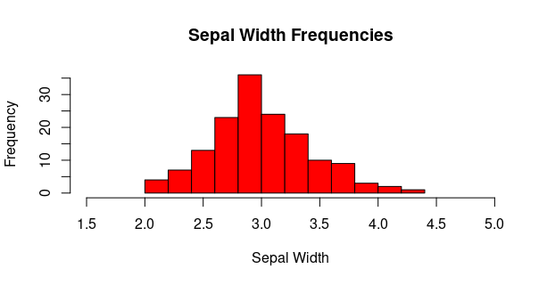
3. Petal Length

> hist(iris$Petal.Length, main = "Petal Length Frequencies", xlab ="Petal Length", col="Green")

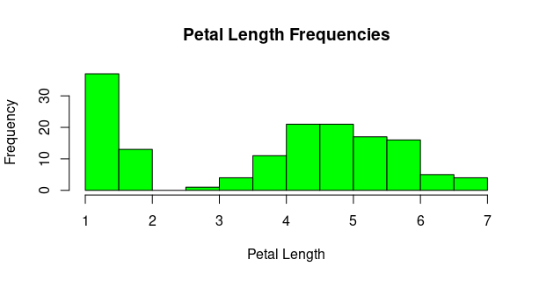

4. Petal Width

> hist(iris$Petal.Width, main = "Petal Width Frequencies", xlab ="Petal Width", col="Yellow")

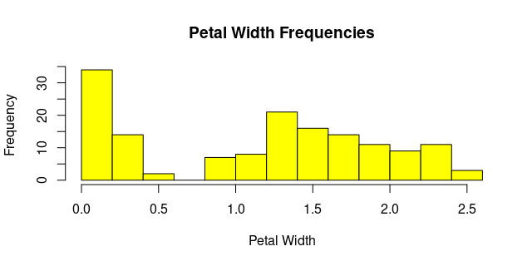

Create a boxplot for each feature in the dataset. All of the boxplots should be combined into a single plot. Compare distributions and identify outliers.

> myboxplot<-boxplot(iris[,-5])
> myboxplot
$stats
[,1] [,2] [,3] [,4]
[1,] 4.3 2.2 1.00 0.1
[2,] 5.1 2.8 1.60 0.3
[3,] 5.8 3.0 4.35 1.3
[4,] 6.4 3.3 5.10 1.8
[5,] 7.9 4.0 6.90 2.5

$n
[1] 150 150 150 150

$conf
[,1] [,2] [,3] [,4]
[1,] 5.632292 2.935497 3.898477 1.10649
[2,] 5.967708 3.064503 4.801523 1.49351

$out
[1] 4.4 4.1 4.2 2.0

$group
[1] 2 2 2 2

$names
[1] "Sepal.Length" "Sepal.Width" "Petal.Length" "Petal.Width"

> myboxplot$out
[1] 4.4 4.1 4.2 2.0

